Swimmer’s name:

D.O.B:

Swimming Location:
Swimming day:
Class time:
Any awards/badges they have received:
Contact number:

Email address:

Parent/guardian’s name:

Signature (by typing your name, you acknowledge the information on the form to be correct):

Andy & Matt
Please complete this electronically and email it to either sutton@suesswimschool.co.uk

GDPR compliance agreement
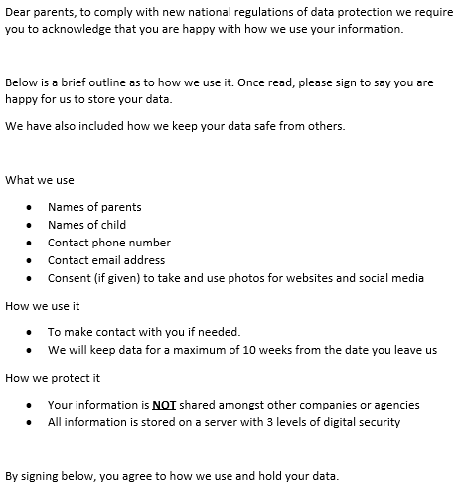
Signature (by typing your name, you acknowledge the information on the form to be correct):

Date:

